Assignment 15

1.
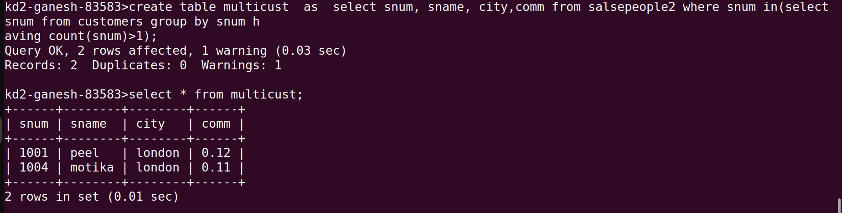

2.

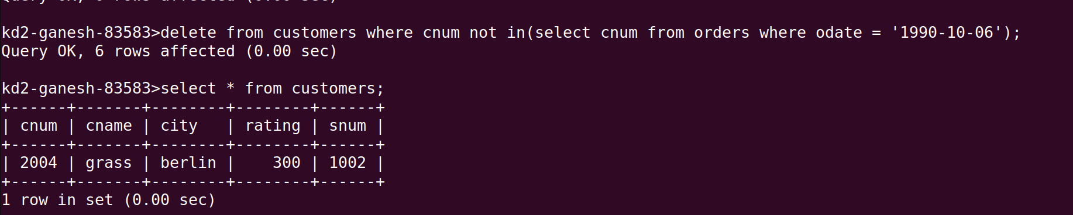
3.

